# Executing parallel test cases in Selenium using GRID

## Importing or Configuring build Path and running the Services

1. Download the Standalone Selenium driver from Selenium website
2. Download TestNG from central Repository of Maven or from Martketplaces.
3. Then try to import the packages and write the code. As below

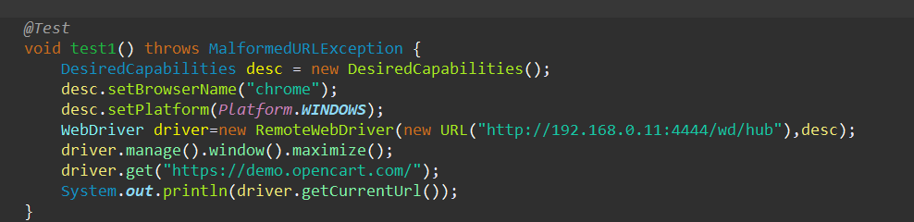

## Running parallel Test cases

1. Write multiple cases with names as test1(),test2();
2. Then convert it to TestNG xml as below
3. 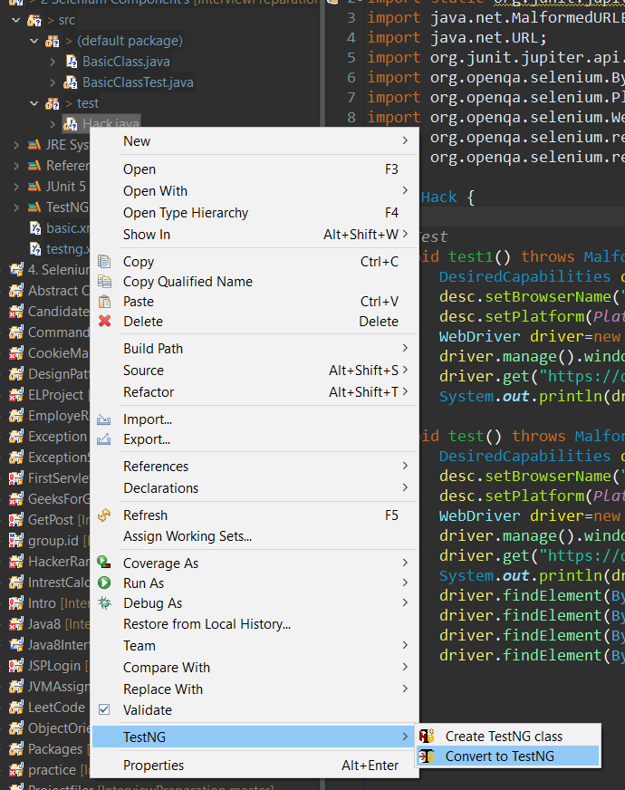
4. You will be presented with a XML file and edit the first xml as below

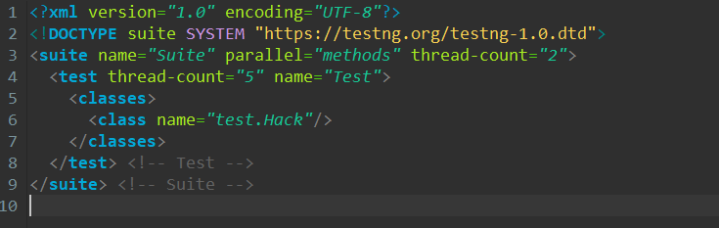

Here Thread count in suite label is replaced with the number of methods you have.

Run the xml as TestNG. All cases will be executed